- Connecting console board with EOC Master console port
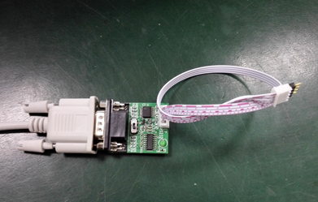
Connecting the Console board with the master console port
Console board
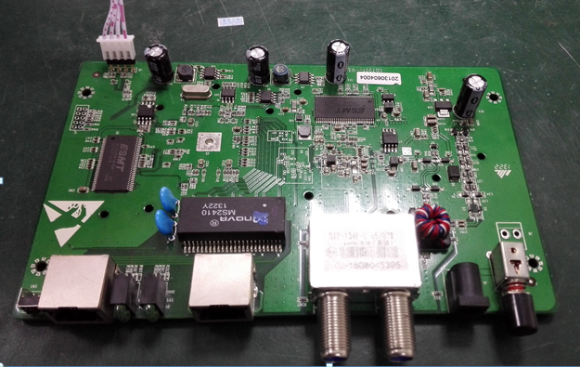

- Log in and get log report

+------------------------------------------+
| Hello, This is |
| EoC System Management Program. |
| Version: V2.4.x |
+------------------------------------------+

EoC CLI starting....

username: admin
password: admin
vtysh> enable
username: admin
password: admin
vtysh# start-shell
#
# cat /var/log/messages

